Software Requirement Specifications,

**School management system**

# Nature of Stakeholders:

1)Administrator: Basic knowledge of computers is a must for this role. Complete access of all the features as well as access of others profile .Creation of username and password is one of the important role.

2. User: Should have the basic Knowledge of computers, can perform user actions as per section

3. Developers: View project’s abilities and Add/Modify additional features for future development as per the requirement. Digitalbuzz have the exclusive rights to develop/maintain/extent the project/project source code and exclusive access to source code.

# OVERALL DESCRIPTION PRODUCT PERSPECTIVE:

A Database is included for more than one user in the MS system. Every user has a unique master key and it will uniquely open the database for each user. Admin provides different username and password for each user. This includes a wide range of sales activities. This software aims at the sales of ticket for each passenger and hence reducing paper work. It also provides day by day reports to keep track of all the sales activities.

# OPERATING ENVIRONMENT:

Processor: Intel dual core or above •

Processor Speed: 1.0 GHZ or above •

RAM: 1 GB RAM or above •

Hard Disk: 20 MB hard disk and above, subject to database size. •

Operating Systems: Windows/Linux

# FUNCTIONAL REQUIREMENT:

# Functional design

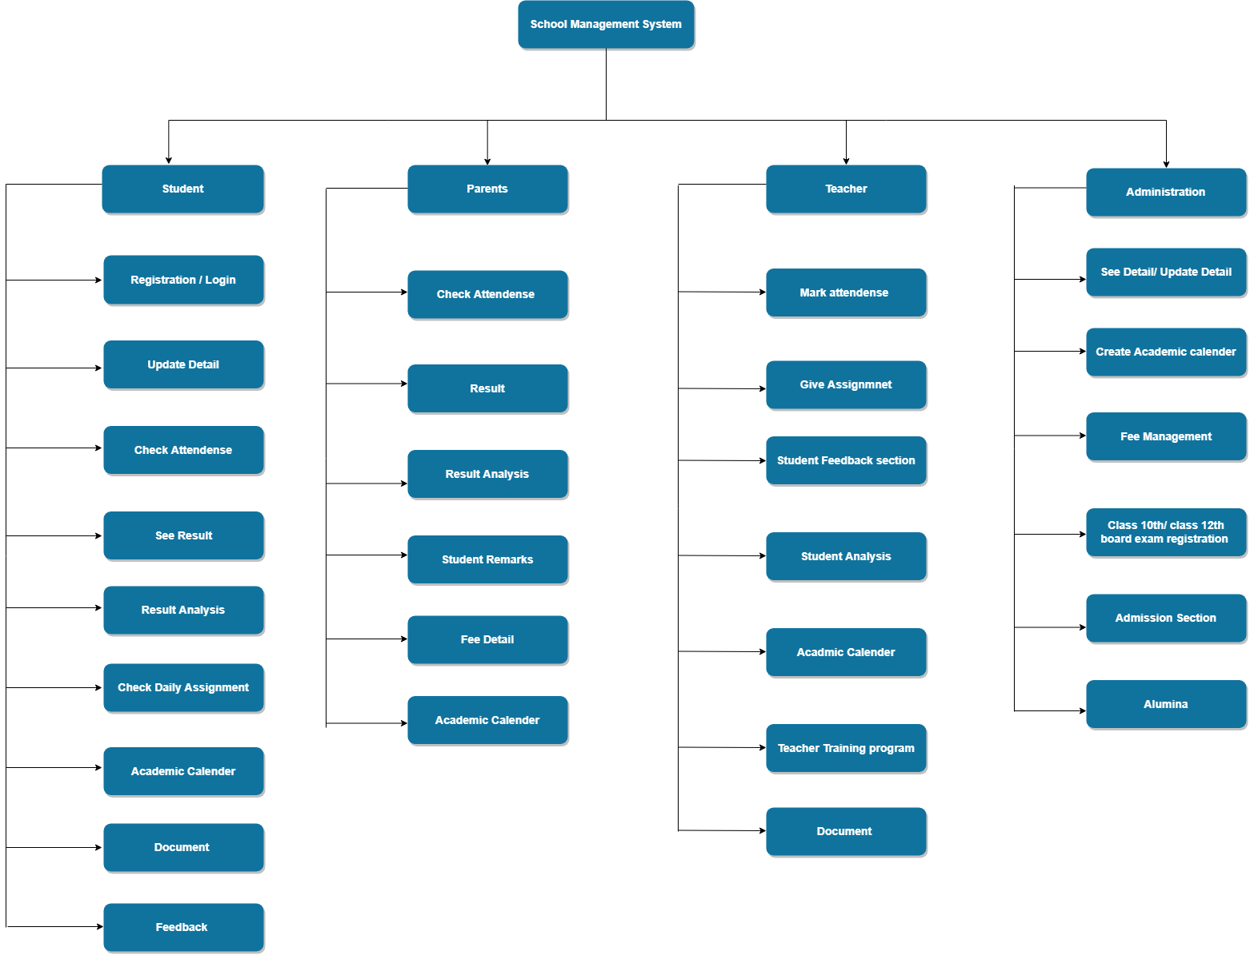

# Description

## Login Module:

Introduction: Authorized users are allowed to access.

Input: User enters the User type, Username and password.

Process Definition:

Checks User type, Username and password is valid or not.

Output: User is directed to next page or shows the message box “Login Failed”.

## Registration module:

Introduction: Any user can access the page.

Input: Admin has the authority to provide username and password for new users Process Definition: Checks same username and password exists or not and also checks whether all the fields are entered.

Output: Employee gets the username and password.

## Report Module:

Introduction: Only Admin can access the page and check the report.

Input: Selected choosen data information

Definition: It retrieve’s all the information stored from different tables.

Output: Requested report is generated.

## Update module:

The details of the students, teachers can be modified on the site. This can be accessed by teachers, students and parents.

## Check and mark attendance

The teachers can upload the attendance of the students and in case of absence a mail will be sent to the parents.

## See Result

The result can be checked on the portal and in-depth analysis can be provided.

## Result analysis

A special dashboard feature added by which the admin as well the teachers,students and parents can do result analysis for the students.

## Daily assignments

The teacher can update the daily assignment on the portal so that it can be tracked by the students and the teachers.

## Academic calender

The yearly calender can be uploaded for everyone reference.

## Documents

The documents can be uploaded for the students reference in case of additional reference

## Feedback

The feedback can be provided by the students to the respective teachersvice versa.

## Fee details

The fee details semwise can be uploaded by the administrator.

## Teacher training program

The information regarding various training programs for the teachers which might be undertaken for the upskilling process.

## Fee management

This feature additionally for the administrator for managing the fees.

## Class 10th/12th registration

The board exam registration process can be initiated.

## Admission details

The details can be shared on the portal adifferent section for the same.

## Alumni

The details of various alumni and a section to keep a track of them and being connected.

## HARDWARE INTERFACES: •

Keyboard and mouse are the input for all the systems designed forms. • Keyboard and mouse will provide user friendly interaction between the user and the system and the forms can be viewed through a monitor.

## SOFTWARE INTERFACES: •

Application Package must be installed. • A confirmation prompt is presented by the system to the user like continue or cancel operation, if any modifications to be done. • All the data’s inserted will be stored in SQL.

# OTHER NONFUNCTIONAL REQUIREMENT:

PERFORMANCE REQUIREMENT: • Good memory space is required. • Should be Error-free. • Large amount of data should be handled easily.

SAFETY REQUIREMENT: • Backups need to be done by administrator.

SECURITY REQUIREMENT: • A password is given to the SQL server. • Administrator and the end user, who have their own user name and password, have only the right to open the software.

# SOFTWARE QUALITY ATTRIBUTES:

PORTABILITY: • Installation of this software can be done any number of times on the lisenced server. If software needs to be installed on other server, earlier installation must be deinstalled and DigitalBuzz must be informed regarding the change.

FLEXIBILITY: • As the transaction takes place, the system keeps on updating the data.

RELIABILITY: • Validations even for user inputs will be done. • Avoid incorrect storage of

records.

The diagram shows various options which can be accessed by various users such as Students, Parents, Teachers and Administration:-